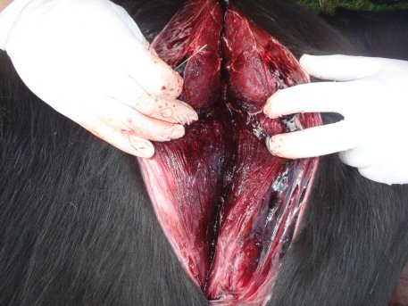

**Organ:** skeletal muscle (bovine)

**Lesion:** leg musculature with blackish-red discoloration with bubbly appearance.

**Etiology:** Clostridium chauvoei

**Diagnosis:** black leg (Acute clostridial myositis)

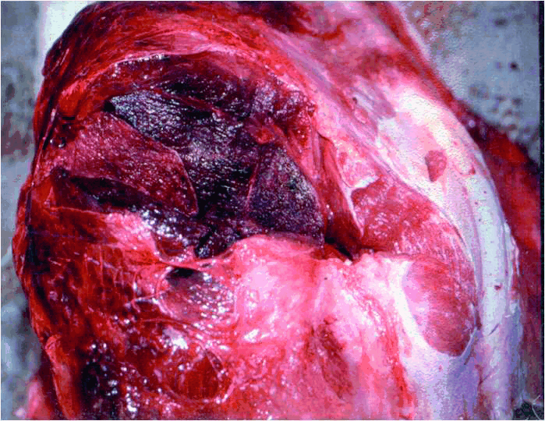

**Organ:** skeletal muscle (bovine)

**Lesion:** leg musculature with blackish-red discoloration with bubbly appearance.

**Etiology:** Clostridium chauvoei

**Diagnosis:** Black leg (Acute clostridial myositis)

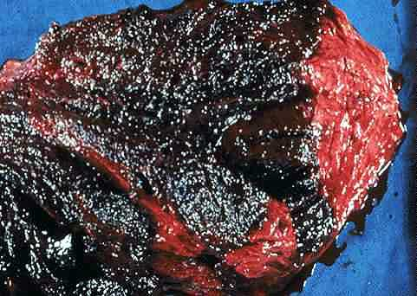

**Organ:** skeletal muscle (bovine)

**Lesion:** extensive necrosis of the leg musculature with a blackish-red discoloration with a "bubbly" appearance

**Etiology:** Clostridium chauvoei

**Diagnosis:** Black leg (Acute clostridial myositis)

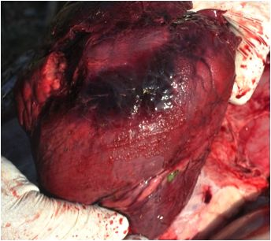

**Organ:** Heart

**Lesion:** The heart showed dark red patch of myonecrosis and fibrin tags.

**Etiology:** Clostridium chauvoei

**Diagnosis:** Black leg

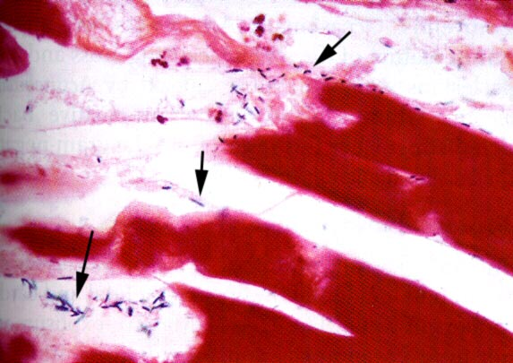

**Organ:** skeletal muscle

**Lesion:** microscopic examination of this tissue shows damage to muscle cells including extensive vacuole formation; a Gram stain is positive for a rod-like organism (arrows)

**Etiology:** Clostridium chauvoei

**Diagnosis:** Black leg

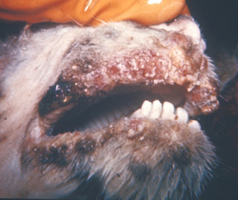

**Organ:** lips (Goat)

**Lesion:** Papules and crusts interspersed with erosions extensively disfigure the lips.

**Etiology:** Orf virus, genus Parapoxvirus in the family Poxviridae.

**Diagnosis:** Contagious ecthyma (Orf)

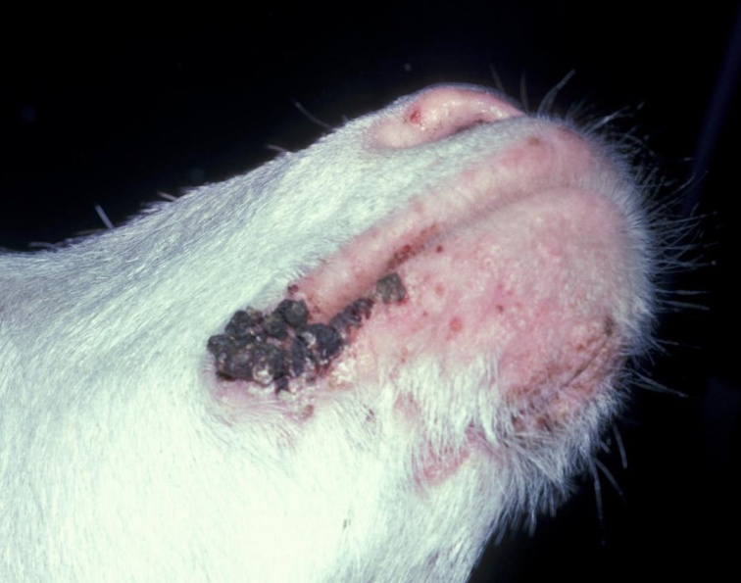

**Organ:** lips (Goat)

**Lesion:** Raised, crusted lesions are centered on the commissure There are smaller papules on the chin and nostril.

**Etiology:** Orf virus, genus Parapoxvirus in the family Poxviridae.

**Diagnosis:** Contagious ecthyma (Orf)

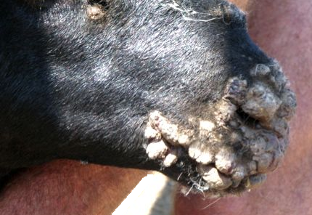

**Organ:** mouth and muzzle (sheep)

**Lesion:** Typical, dry scabby lesions on the mouth and muzzle.

**Etiology:** Orf virus, genus Parapoxvirus in the family Poxviridae.

**Diagnosis:** Contagious ecthyma (Orf)

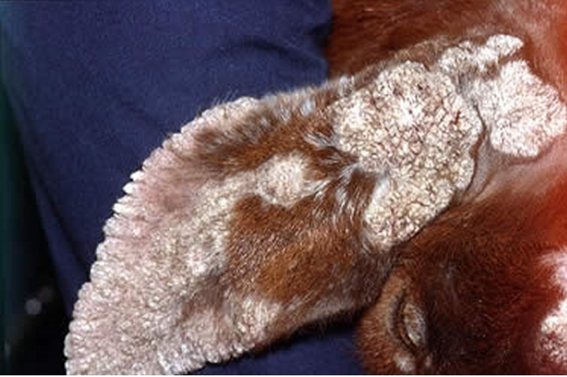

**Organ:** Ear (goat)

**Lesion:** Typical, dry scabby lesions on the ear of goat.

**Etiology:** Orf virus, genus Parapoxvirus in the family Poxviridae.

**Diagnosis:** Contagious ecthyma (Orf)

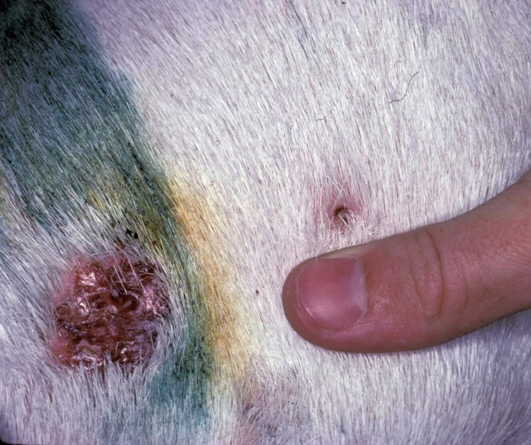

**Organ:**  skin (Goat)

**Lesion:** The skin is focally alopecic, thickened and reddened.

**Etiology:** Orf virus, genus Parapoxvirus in the family Poxviridae.

**Diagnosis:** Contagious ecthyma (Orf)

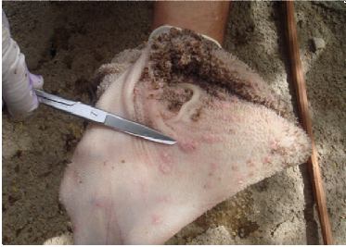

**Organ:**  Rumen and reticulum (sheep)

**Lesion:** there is proliferative papules lesion on the mucosa of the rumen and reticulum.

**Etiology:** Orf virus, genus Parapoxvirus in the family Poxviridae.

**Diagnosis:** Contagious ecthyma (Orf)

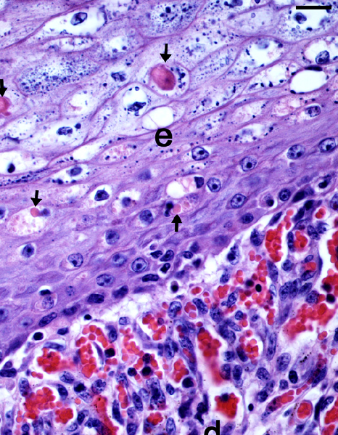

**Organ:**  Skin

**Lesion:** intracytoplasmic eosinophilic inclusion bodies (arrow) are seen in degenerating keratinocytes in the epidermis (e) of an acthyma lesion in the skin, also note the dilated capillaries in the subepidermal area (d). (H& E stain)

**Etiology:** Orf virus, genus Parapoxvirus in the family Poxviridae.

**Diagnosis:** Contagious ecthyma (Orf)

**Organ:**  calf foot

**Lesion:** calf foot seen from the bottom of foot. Note how the swelling is so severe that it pushed the toes apart.

**Etiology:**

Dichelobacter nodosus or/and

Fusobacterium necrophorum

**Diagnosis:** Foot rot (infectious pododermatitis)

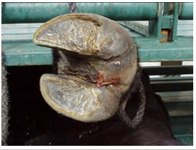

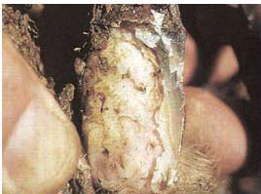

**Organ:**  sheep foot

**Lesion:** Severe form of the disease involving the sole with extensive inflammation and under running of the hard horn of the hoof.

**Etiology:**

Dichelobacter nodosus or/and

Fusobacterium necrophorum

**Diagnosis:** Foot rot (infectious pododermatitis)